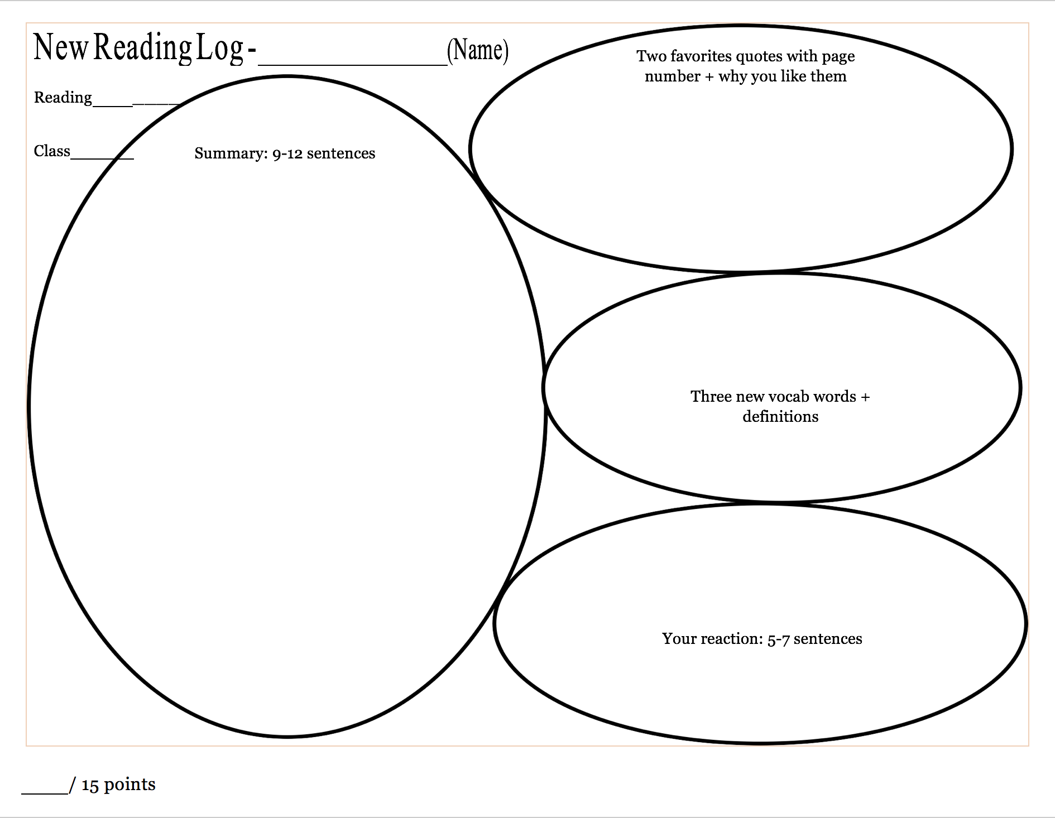

I was very inspired by this Wikipedia page because I didn’t know that one of my favorite brands and the world’s most high-end, renowned, and recognized fashion brand started off as a workshop that dedicated on a type of craft that I’ve never even heard of and was a luxurious craft in Europe in the era when the brand was created. Also, I never knew that Louis Vuitton had his parents died when he was just a kid and had to walk for 470-km and worked as an employee for someone for 17 years to start his business. This will be a legend that I will keep in my mind to keep me motivated.

Apprentice practitioner urbane renowned monogram

“Securely packs the most fragile objects. Specializing in packing fashions.” that was my first favorite quote because it was the line that was written and hung in front of his fist work shop so it gave me a very fascinating picture of Louis Vuitton standing on a chair and hanging that line up 165 years ago.

“She charged him with ‘packing the most beautiful clothes in an exquisite way.’” that was another favorite quote for me because at first, the word ‘charge’ made me think that he got a lawsuit but then it was not lawsuit but something positive, so I like how they played me like that.

This Wikipedia page talks about Louis Vuitton, the creator of Louis Vuitton the fashion brand. It talks about his early life, work and career, and death. He was born on the 4th of August, 1821. One empathetic feature of his life was that both of his parents died when he was just about 10. One very brave decision that he took was to walk, yes walk, 470-km from his native, Anchay to Paris to find a better life at the age of 13. When he got there, he was 16 and worked as a box-making (a kind of craft) and packing apprentice at a workshop. He was married to Clemence-Emilie on 1854, when he was 33 and she was 17. Pedo alert!! In the same year that he got married, he left that workshop to open his own box-making and packing workshop, Louis Vuitton, in Paris. Besides owning this shop, Louis got hired to personally make boxes and craft for the Empress of France, Spanish countess Eugenie de Montijo, along with many other royals that Eugenie de Montijo later on introduced him with. He worked until his death on the 27th of February, 1892 when he was 70.