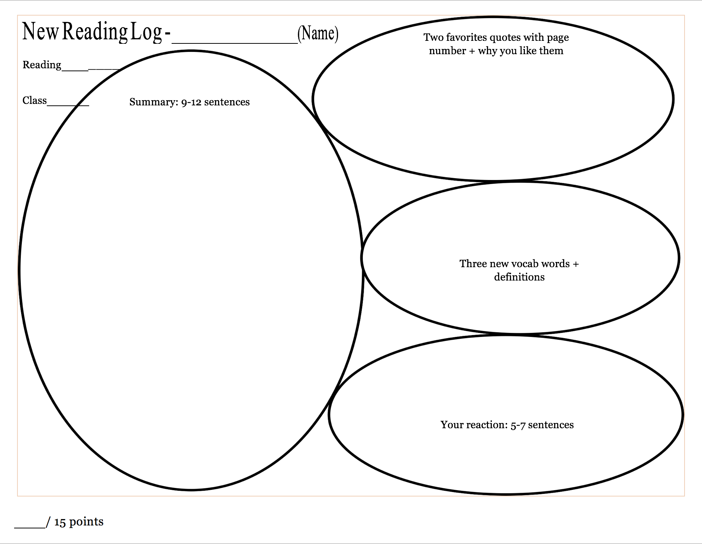

I am a fan of Yohji Yamamoto because his designs are clean and alluring. I also like his idea of fitting women in men’s. clothes. His bail on engaging in a law career to switch to designing gave me the motivation to begin something or restart when I fail or find out that something does not suit me. Lastly, I admire that he is still making sick designs at this age.

Foster debut prospective avant-garde aesthetic

“When I started making clothes for my line Y’s in 1977, all I wanted was for women to wear men’s clothes.” I liked that because that was a very interesting and one-of-a-kind deed of a designer.

“But above all black says this: ‘I don’t bother you - don’t bother me’.” I liked this quote because that was a dope line that can apply on people who annoy me and haters.

This is one more Wikipedia page that have read about a person and that person like the two others that I read about on Wiki is a fashion designer which is Yohji Yomamoto. This page talks about the early life and designing career of him. He was born on the 3rd of October, 1943 (a day before my birthday) and now he’s 75. He was born in Tokyo, graduated from Keio University with a law degree in 1966 and then gave up on that path to go study fashion designing at Bunka Fashion College and got a degree in 1969. He first debuted in Paris in 1981. Initially, when he entered the fashion industry he wanted to make men’s clothes for women and he still does. He likes black and most of the clothes he make are black. Three of his brands are YOHJI YAMAMOTO, Y’s, and Y-3. It’s reported in 2007 that his two main lines YOHJI YAMAMOTO and Y’s made $100 million annually. He had also won awards for his contributions to fashion, including the Chevalier of [Ordre des Arts et des Lettres](https://en.wikipedia.org/wiki/Ordre_des_Arts_et_des_Lettres),[[3]](https://en.wikipedia.org/wiki/Yohji_Yamamoto#cite_note-vogue-3) [Medal of Honor with Purple Ribbon](https://en.wikipedia.org/wiki/Medals_of_Honor_(Japan)), the [Ordre national du Mérite](https://en.wikipedia.org/wiki/Ordre_national_du_M%C3%A9rite), the [Royal Designer for Industry](https://en.wikipedia.org/wiki/Royal_Designer_for_Industry) and the Master of Design award by [Fashion Group International](https://en.wikipedia.org/wiki/Fashion_Group_International).