  - New Document
Mr Mohammad Salleh is a very successful business man. Today, he is the manager of two companies and Chairman of six other companies.
Mr Mohammad Salleh came from a very poor family. His father could hardly give him any money to buy books. Mr Mohammad Salleh therefore worked in a coffee shop in the afternoon. He studied very hard.
After graduating as a lawyer, Mr Mohammad Salleh could not find a job as a lawyer, so he worked as a salesman.
  - Selecting and Changing
She has three pets.
He has ten animals in his family.
We have five cats in our house.

  - Cut and Paste
Get the tin from the cupboard.
Open the tin.
Put the beans in the pan.
Put the beans on the plate.

Put the tea in the pot.
Add hot water.
Pour the tea.
Add the sugar.
Drink it.

Go to the pool.
Get dressed.
Pay at the counter.
Swim for twenty minutes.
Get dry.
Put on your costume.
  - Spellchecker

  - Long Documents
Eat more local fruits
A lot of Malaysians like to eat imported fruits. In fact Malaysia produces a seemingly endless variety of tropical fruits. Bananas, papayas, pineapples and watermelons are available throughout the year. Some other fruits like rambutans, durians, mangosteens and langsat are only seasonal.

  - Amend Text for a Specific Audience
Eat more local fruits
A lot of Malaysians like to eat imported fruits. In fact Malaysia produces a seemingly endless variety of tropical fruits. Bananas, papayas, pineapples and watermelons are available throughout the year. Some other fruits like rambutans, durians, mangosteens and langsat are only seasonal.

  - Insert Images
Eat more local fruits 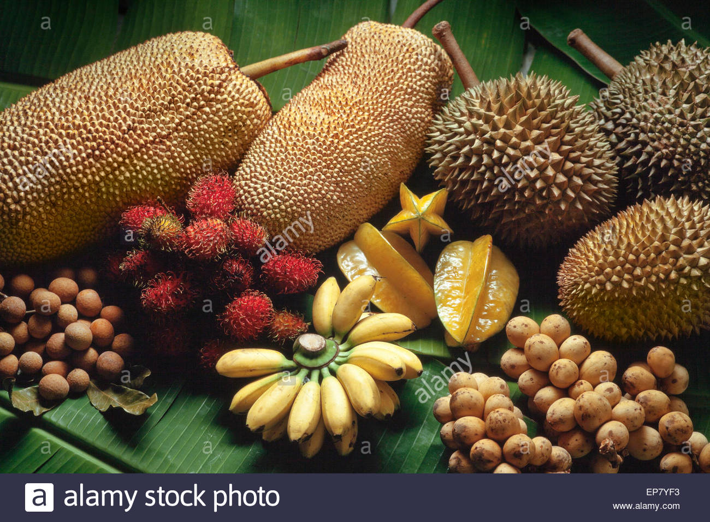
A lot of Malaysians like to eat imported fruits. In fact Malaysia produces a seemingly endless variety of tropical fruits. Bananas, papayas, pineapples and watermelons are available throughout the year. Some other fruits like rambutans, durians, mangosteens and langsat are only seasonal.

  - Word Art

Stay awsome bros
Cambridge ICT Starters

Cambridge ICT Starters

Cambridge ICT Starters

  - Refine and Organise
Eat more local fruits
A lot of Malaysians like to eat imported fruits. In fact Malaysia produces a seemingly endless variety of tropical fruits. Bananas, papayas, pineapples and watermelons are available throughout the year. Some other fruits like rambutans, durians, mangosteens and langsat are only seasonal.

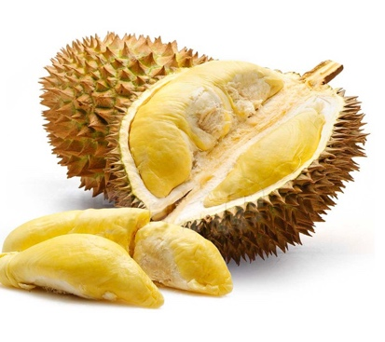
According to research, the Malaysian local fruits are very nutritious and rich in vitamins as well as minerals. They are as good, if not better, than imported fruits. Fruits like bananas, papayas, starfruits are even of high medicinal value. We therefore should eat more local fruits.

Furthermore local fruits season is an attraction to tourists to visit Malaysia. It is also a profitable time for most orchard farmers.
Nutritious & Delicious!

