!!! Sugar is dangerous !!!
An average person should only take in 18 grams of sugar a day and did you know that a can of soda, a bar of candy, chocolate and ice cream have more than the amount of sugar you should take a day! That means that if you drink a can of soda and eat a candy bar or ice cream, That’s More than the amount of sugar you should take a day entered your body already!

And do you know what will happen to you if you take too much sugar?
You will have cancer, acne, dental issues, diabetes, headaches etc.
14.5 million people have cancer
17 million people have acne (that’s only in U.s)
29.1 million people have diabetes (that’s only in U.s)
What are cancer, acne, dental issues?
Diabetes is a disease in which your body cannot control the level of sugar in the blood
Cancer is a serious disease that is caused when cells in our body grow in a way that is uncontrolled and not normal, killing normal cells and often cause death
Acne is having a lot of pimples on your face
Dental issues are problems that happens to teeth and your gum
Headaches are pains we feel inside our head

Cancer
Acne
Dental issues
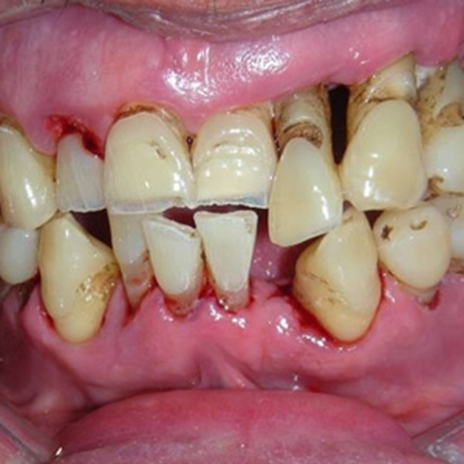
Headaches
You can save yourself by eating less sugar from now!

